HOA Toolkit v. 2.0 Release Notes (11/25/2020)

Updated UI (TileUI)
- Properties has been renamed Portfolio.
- + Property moved to top right corner to provide more usable screen area.
- Use the refresh icon to redownload data for just one Property (can still use Download Community Data to Device button to re-download all).
- Use the carrot icon to see additional options for Property. Currently this has the Settings button, but more functionality will appear when added to the app.
- Property Settings – takes you to new settings page, specific for each Property (this is inherited from Company settings under the More options below.)
- Company Settings – accessed from the More tab, takes you to settings for all of the Properties for your management company. These settings are used for all properties, unless overridden at each property.

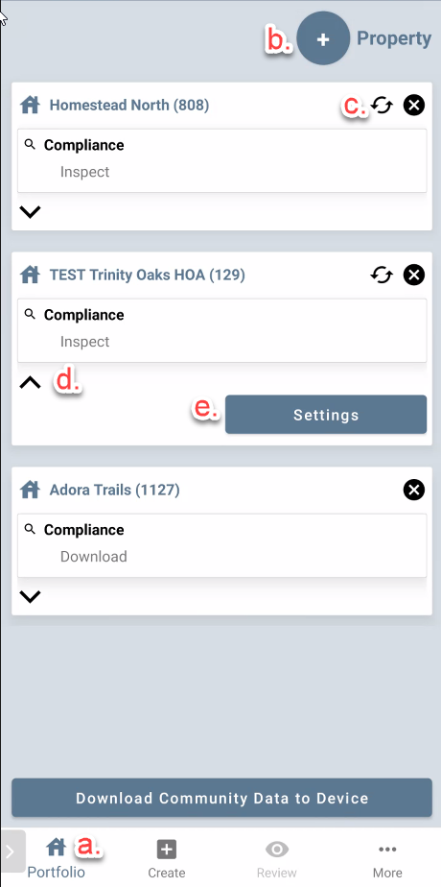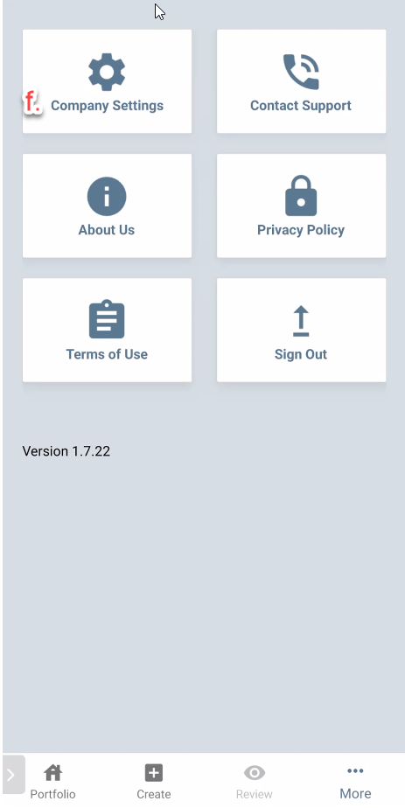

Ability to auto-notify by email on inspection completion
Upon submitting an inspection, an email will go out to the email address specified for each Property in the Property settings. This email address is inherited from the Company Settings, but can be overridden and each community can have its own notification email. Important – do not change the email address that is the default for your Management Company unless instructed to do so by your compliance team as it has been accurately preset for your Company.

- Completion Notification ON/OFF toggle and email address.
- Load defaults – this will load your Management Company approved defaults. If you need to revert back to the approved company settings, tap this.
- OK – tap to save changes.
- Property Settings inherit default Management Company settings; to turn off inheritance tap on the toggle. To override the notification email per property, first tap the toggle to turn off inheritance, then you can modify the notification email. Toggling the “follow Management Company” settings to ON will restore default Management Company settings.

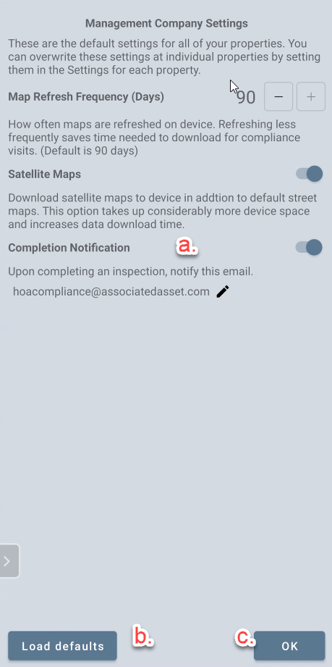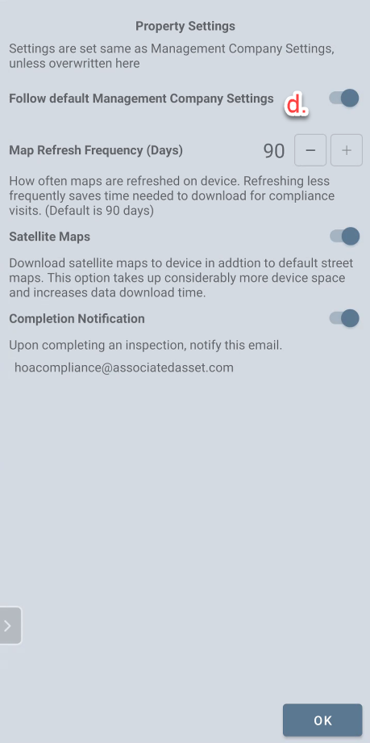

Sample Email
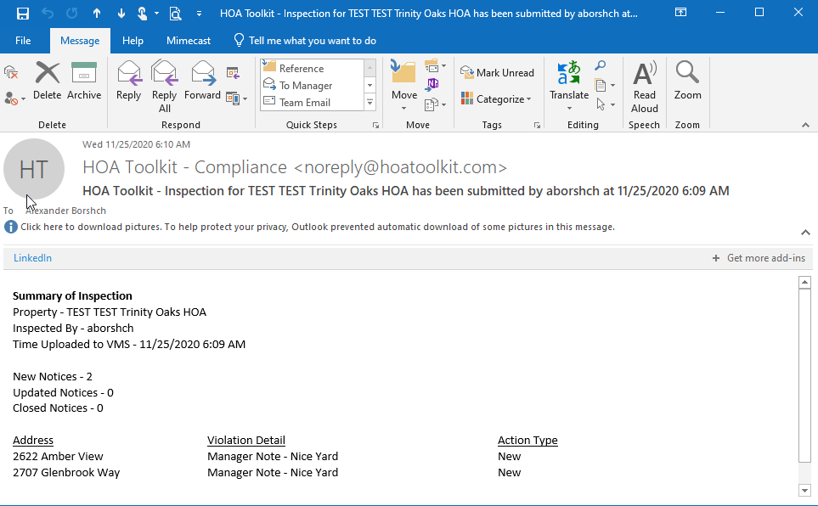

The email is generated per each property submitted and includes information on the counts of violations, time of submission, inspector, and violation detail.

Pop-up notification if inspections have not been submitted after an hour
One hour after you have created your last inspection, if you have not submitted the inspections to VMS, a notification pop-up will be generated on your phone. This is to remind you to submit to VMS, in case you have forgotten.

Settings to control satellite map and map refresh frequency
- Map refresh frequency (1, 7, 30, 60 or 90 days) – how often maps are downloaded to your device. By default, maps are downloaded the first time you add a Property to your Portfolio and are not refreshed for 90 days. This saves a considerable amount of time on refreshing data for inspections, as only the inspection data is then refreshed, and not the maps (a difference of up to several minutes of download per property). However, you may choose to refresh maps more frequently with this setting.
- Toggling the setting to OFF will prevent Satellite Maps from syncing to your device, which saves considerable hard drive space and download time, if you are not in need of those maps. Regular street maps are always available on device as they require minimal space.
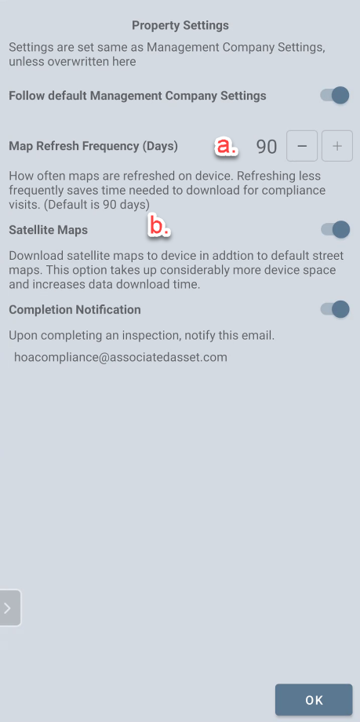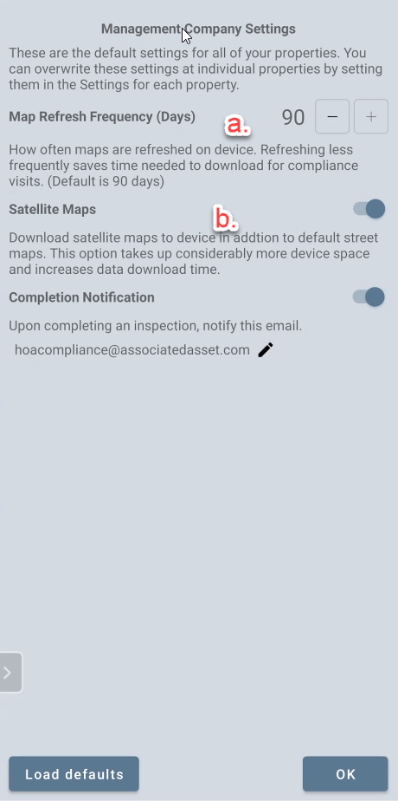

Keeping map zoom level in memory between inspections
You are able to zoom in and out on each map by using the expand/collapse gesture with two fingers – the zoom level you use last will now be saved between inspections, so you always have the zoom level preferable to you and your device.

Inspection Group as new filter type
For properties set up with an inspection group, it is now an available filter on (b.). Access from the Filter Icon (a.)
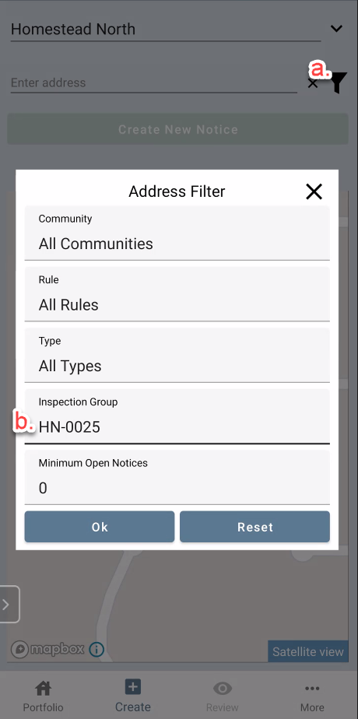

Fixed occasional errors on first data sync to device
Added more tolerance to property sync from client servers, to eliminate data sync errors.

Added quicker property addition with active cursor
When tapping on the + Property to add to Portfolio, the pop-up loads up with a blinking cursor ready for property selection, eliminating extra screen taps.

