HOA Toolkit v. 2.1 Release Notes (12/11/2020)

Ability to select/override next sequence
*setting enabled if requested by Customer, otherwise next in sequence is enabled by default
- The action will default to next action in sequence, but you can tap it to bring up a menu to override with a different action. Actions to choose from are grouped under In Sequence, Frequently Used, and Out of Sequence, and are specific to your VMS implementation, reflecting what you have defined in the system. To change these, you would update your VMS configuration.
- By default, the next sequence is selected, but you can override with any sequence.
- If you select Hold, you will be prompted for the Hold Until Date to populate into VMS.
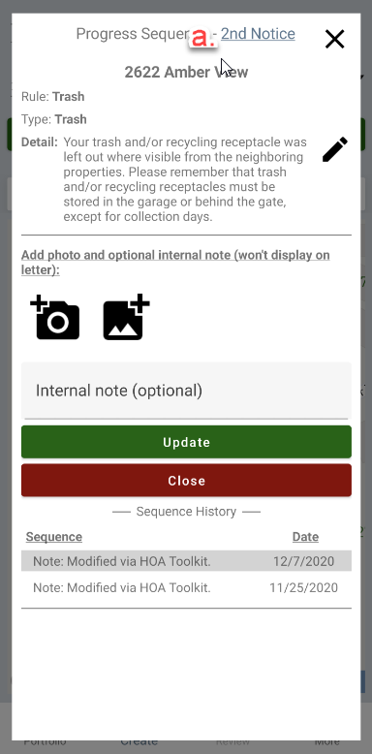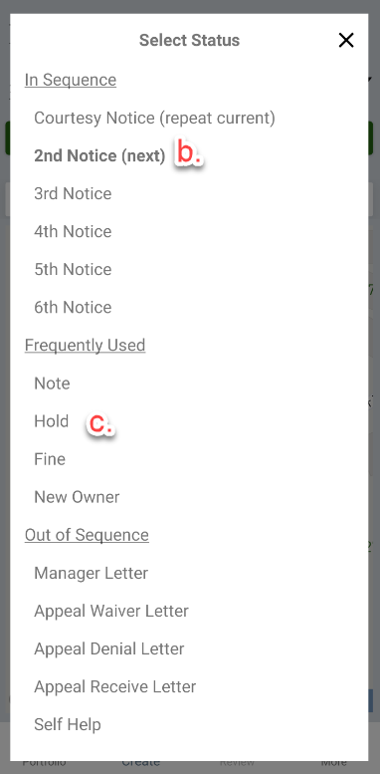
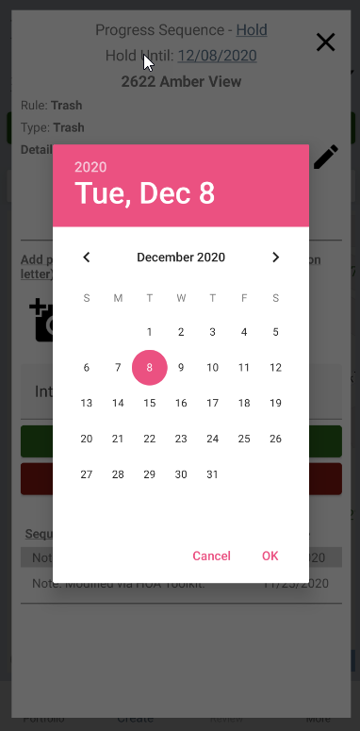

Adjustments to inspection confirmation email
- Adding inspection time (as opposed to only submission time).

UI adjustments
- Changing button name to “Download Portfolio to Device” for clarity.
- Hiding drop down arrow after adjusting settings.
- Changing icon for sign out button.

Bug fixes
- Confirmation email detail – occasional inaccuracies.
- Inspection creation page – showing “no notices” when notices exist.
- Inspection creation page – showing incorrect sequence name.

