HOA Toolkit v. 2.1 Release Notes (12/18/2020)

New unsubmitted notice indicator/counter
- Upon creating/updating/closing a notice, a red counter circle will now appear above the Review button in the bottom tool bar. The number will increment and reflect the number of modified notices unsubmitted on the device. Tap on the Review button to go to the Unsubmitted Notice review screen.
- The old unsubmitted notice review button at location b will not appear anymore, saving screen space to show more of the notice history and the map.

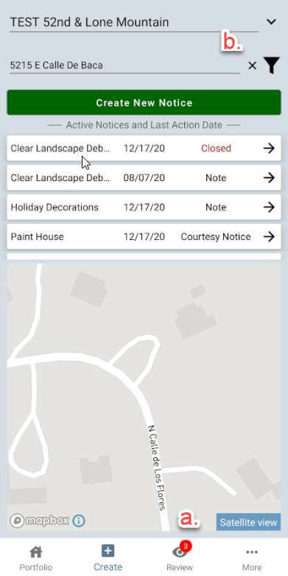

Enter address list starting on last entered address
Prior to version 2.2, when tapping on the “Enter Address” field, the result list always started at the smallest number/street name in the property. Starting with 2.2, when tapping on the Enter Address field, if there was a prior address entered, the list will start at the prior address entered. This allows the inspector to navigate down the street quicker by having the list move down in succession to the next house, if using the list instead of the map.

Scroll bar added on rule type selector if not all options fit on screen

Bug fixes - geolocation
Geolocation issues on some devices have been fixed. This includes the blue icon (indicating inspector location) not appearing on some maps and some maps not “following” the inspector navigating through a property.

Bug fixes – note text selection
If a note text stored in VMS did not end with a zero, it would display as … in HOA Toolkit before. This has been fixed to display all notes accurately.

