HOA Toolkit v. 2.3 Release Notes (01/22/2021)

Last Action Before Date filter
- You can now filter inspections by the last date it was acted on, which allows to identify and address inspections open longer or during a certain time span.

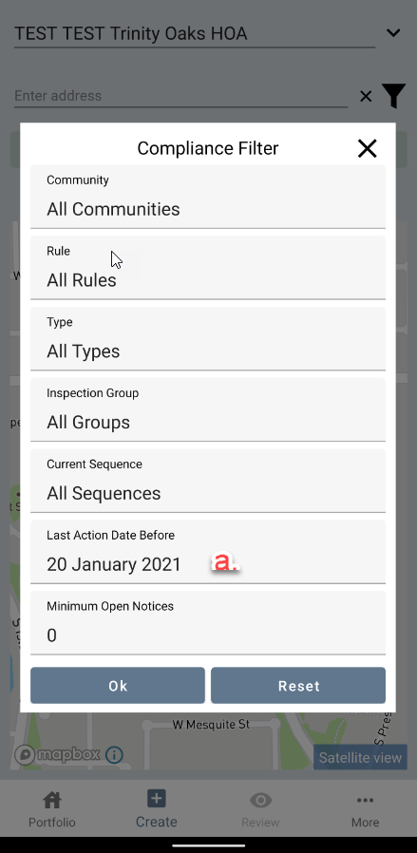

Map Improvements
- Active unit highlighting –the actively selected address will be highlighted on the map, for easy identification.
- Satellite map unit background – white background on unit numbers on the satellite maps makes identifying units easier.

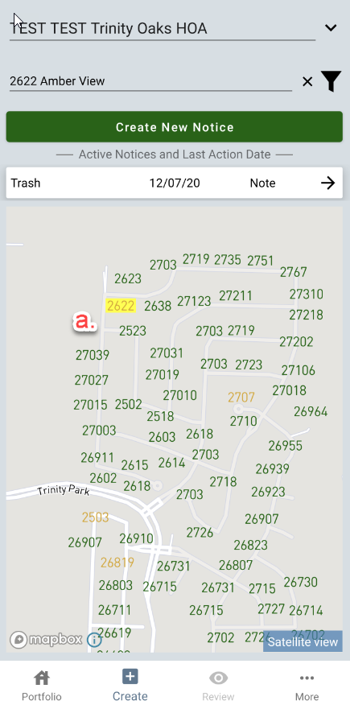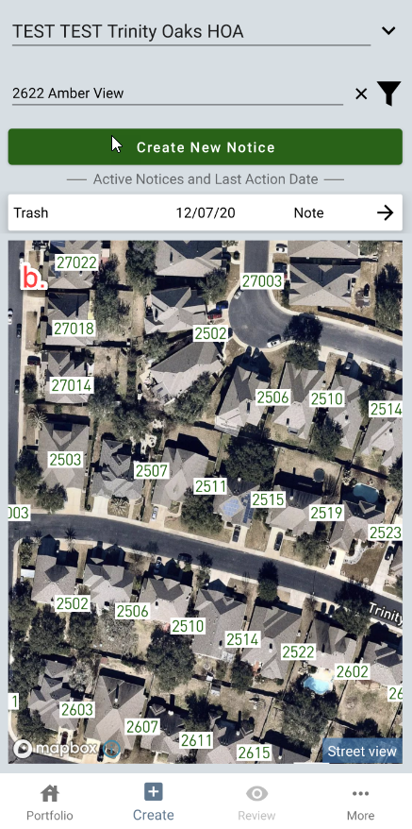

Current Sequence Filter grouping
- Sequences now grouped into logical groups. Tap on a sequence to select or tap “All Sequences” for all.
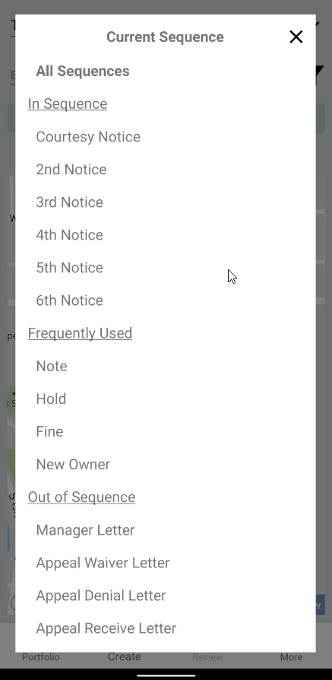

Auto-capitalization on entering note detail

Photo timestamp now shows local time
- Photo timestamps used to show UTC time, but will now show local. If you do not have photo timestamp active on your photos but would like to, please reach out to your Hestia rep.

Conflict Resolution
- We are now checking if a base compliance issue was deleted from VMS after it was downloaded to local device and alerting the user.

User Interface improvements
- Decreased space between property tiles in Portfolio to allow more properties to fit on screen.
- Narrowed download progress bar for aesthetics.

