HOA Toolkit v. 3.0 Release Notes (04/30/2021)

NOTE: Some of the features in version 3.0 require the latest VMSRxchange web service rolled out by VMS. If you do not have the latest version, your app will continue to function as before, but without some newer features. We will notify customers when the latest web service is available and VMS support can update it in the month of May.

Icon-Centric Portfolio Interface
With the introduction of the new Resident Module we are shifting the portfolio interface to be icon-based to provide a better user interface for using different modules. New modules will receive new intuitive icons.
The compliance icon now consists of a dim unselected magnifying glass and a down arrow to indicate properties that need to be downloaded to device (Sun Groves in the example below) and when the property is downloaded and ready to Inspect, the icon will become a bright magnifying glass with no down arrow (Test Trinity Oaks below).
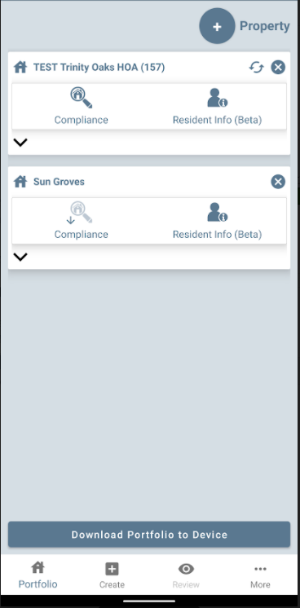

Resident Info Module (Beta)
The Resident Info module allows application users to review and edit resident account information. Please note that the module will be deployed to beta users first and then to the rest of our customers starting 5/7/21 and will appear in your app when ready for your company. By default, the module will be deployed in read-only mode, but is available in edit mode where users can edit contact information of the account – please contact Hestia if you want edit mode to be activated.
In version 3.0, the Resident Info comes in ONLINE and OFFLINE modes.
ONLINE – without downloading compliance first, you can search for residents, see information and update information (if enabled). This requires Internet.
OFFLINE – if you download Compliance to device first, this will also download resident info to device and will not require Internet in the field to view Resident Info. Updates to data do currently require Internet.
- Accessing the module – tap on Resident Info in Portfolio or on the icon next to the selected address.
- Tapping next to the selected address (b) will automatically bring up that account info.

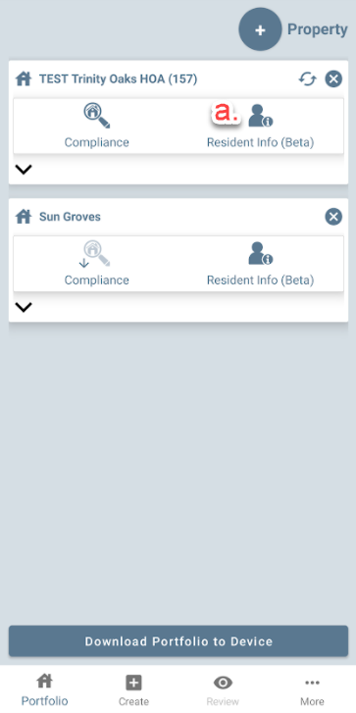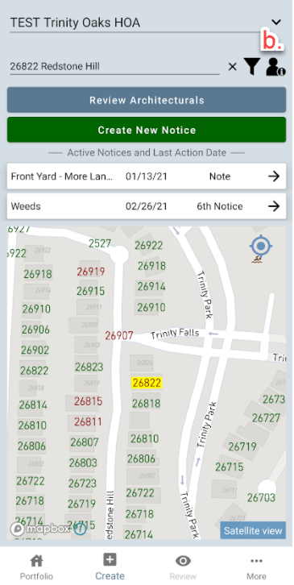

- Searching for account – search by starting to enter either the house number, street, name or account number.
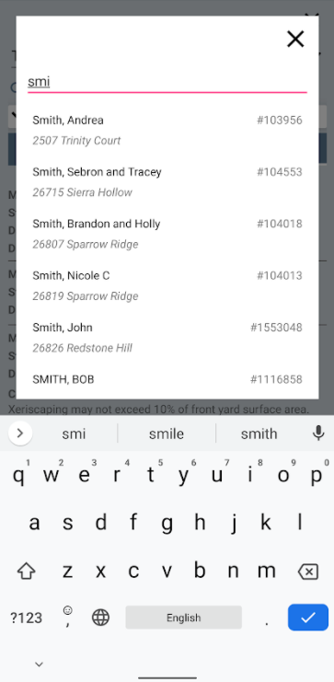

- Contacts – presents contact and account info. The ^ symbol can be used to minimize and maximize the account info. The following info can be viewed and edited (if enabled):
    - Account type/contact type
    - Phone numbers (tap phone to call and message to message contact)
    - Date of Birth
    - HOPA Dates
    - Email Address (tap envelope to email contact)

Tap “Edit Contact Info” to bring up the edit screen where you can add or edit contact details.
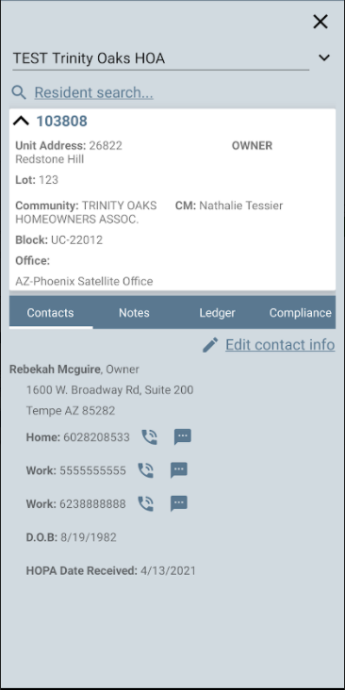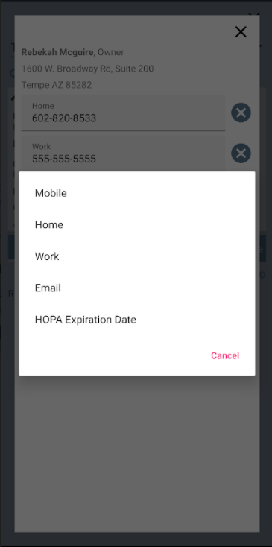

- Notes – allows to view and add/edit account notes.
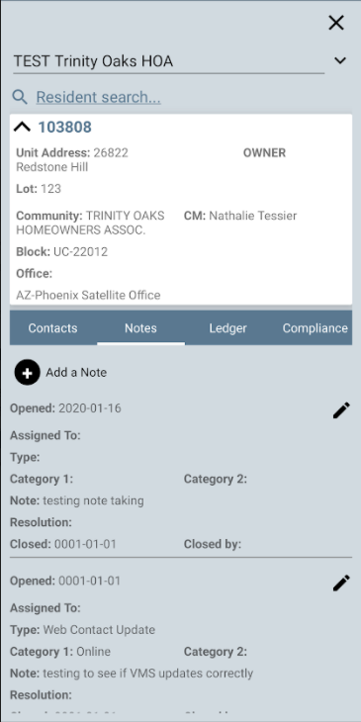

- Ledger – allows the user to view ledger history, there is no edit functionality.
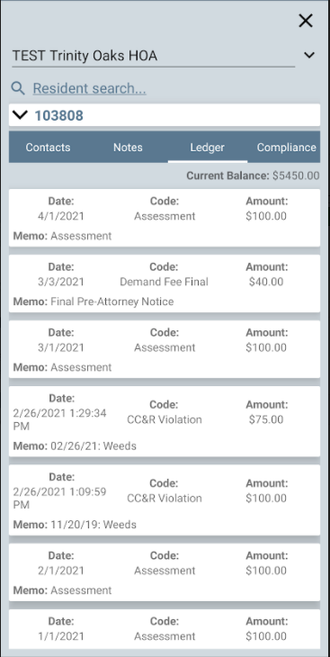

- Compliance – provides historical compliance information on account, including closed violations (all history).

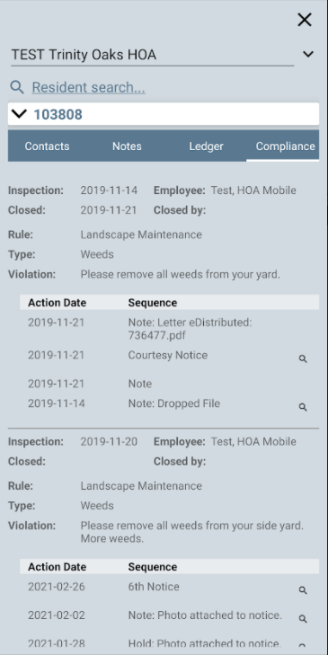

- Arches – provides architectural history

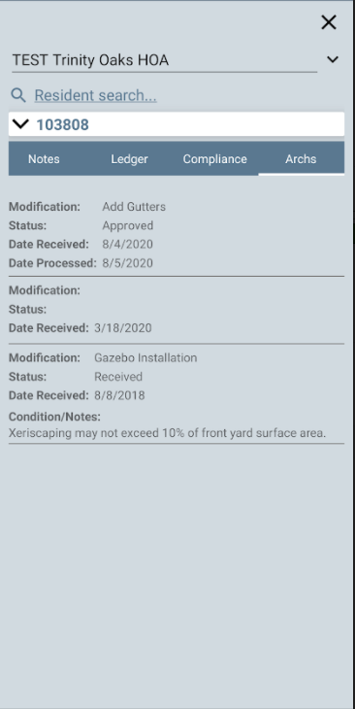

- Note History (Days) Setting
There is a new setting to control how many days of history are synced to the device when using Resident Info in Offline mode. The setting defaults to 90 days but can be changed. The fewer the days of history, the quicker the Property will sync to the device.

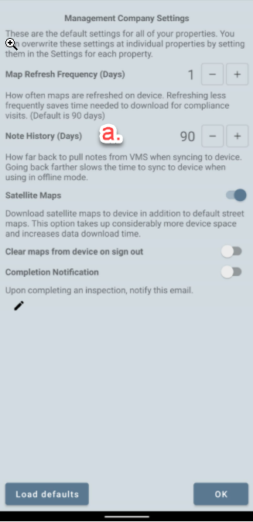

Inspection Date
The original inspection date of the violation now appears on the inspection edit screen. This date is not editable by default, but if your management company needs access to edit the date, please contact Hestia and we can activate the edit mode for your employees.

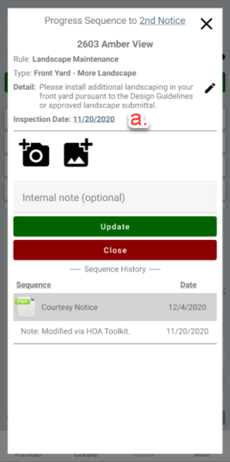

Multiple Communities in Property Selection Behavior
When adding a property to portfolio consisting of multiple communities, prior behavior was to have all communities selected. The new behavior is to have the communities not selected by default, so you are able to select individual communities or still tap “Inspect All” at the bottom to select all. This allows for a quicker selection of individual communities for inspection.

Brighter House Color
Red on houses is now a brighter shade, to easier differentiate from other colors.

In Sequence Action Fix
Under some conditions, compliance actions that are defined as In Sequence in your VMS system were showing as Out of Sequence in HOA Toolkit. This is now fixed and In Sequence actions show correctly.

Minor Bug Fixes
- In rare conditions on download, the app would report a successful download without all addresses having downloaded, this has been fixed.

