HOA Toolkit v. 3.1 Release Notes (05/13/2021)

NOTE: Some of the features in version 3+ require the latest VMSRxchange web service rolled out by VMS on 4/23/21. Hosted customers have been updated but if you have an on prem instance of VMS, make sure to update.

Note Type filter on Resident Notes
- You can now filter by note type in the resident note file.
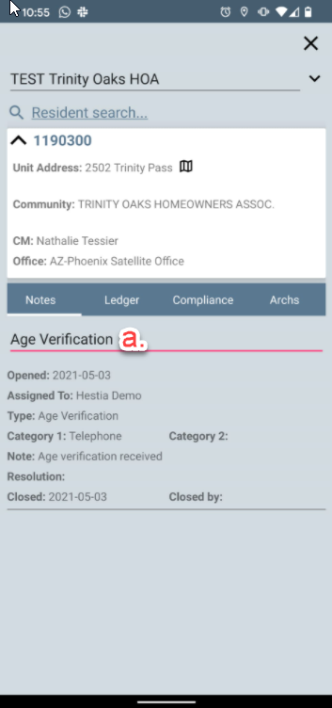

Compliance Status Filter in Resident Info
You can now filter by status of the violation (all/active/closed).
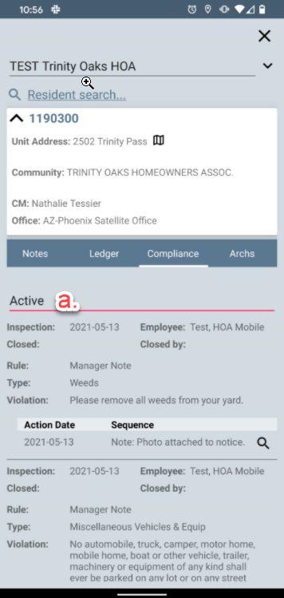

Architectural letters in Resident Info
You can now pull up and view actual architectural letters that were sent out from VMS by tapping the icon on the Arches tab of Resident Info.

Setting to not Sync Resident Info with Compliance Sync
When syncing data from VMS to your device for an offline inspection, by default we also sync Resident Info for offline use, for all customers utilizing the Resident Info module. You can override this behavior by toggling the new setting, which would save time on compliance data sync by not syncing Resident Info offline. If the setting is enabled, the compliance sync would be faster, but the Resident Info would require an Internet connection to query.

Map Navigation Button in Resident Info
- You can get navigation directions to a unit by tapping the map icon on the unit address.
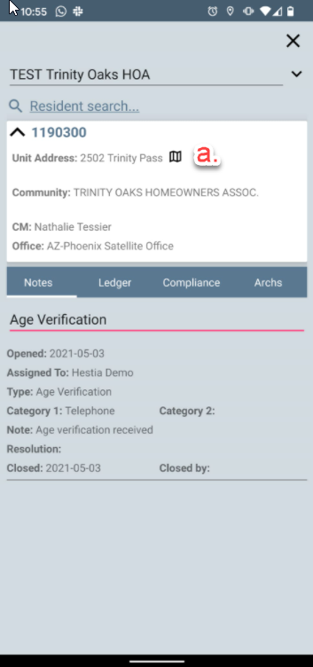

Bug fixes
- Duplicate contacts in search results of Resident Info
- Dark theme rendering on some devices resulted in black fields before, now they are visible.
- Fixed a rare case of confirmation emails not being sent out.

