HOA Toolkit v. 4.0 Release Notes (09/22/2022)

Resident Info module now out of Beta!
Review and update the Resident Account Information in real-time or offline

Ability to select photo size for upload, image quality
Users will now have option to select the image size (resolution) for upload.
- Small – 1/4 of page (877x620 pixels)
- Medium – half page (1754x1240 pixels)
- Full page (3508x2480 pixels)
New image options can be found in HOA Toolkit under More - Company Settings
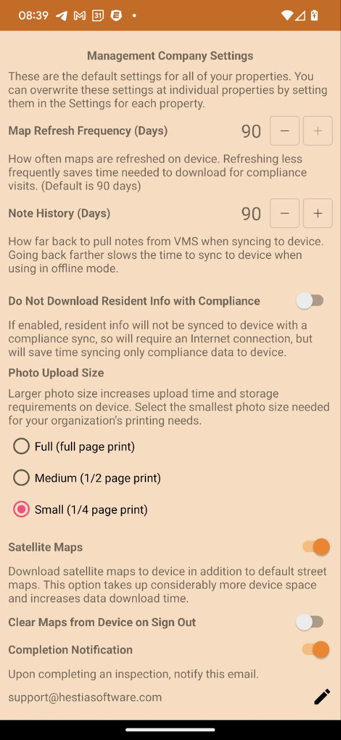
Upload sizes correlate to the violation letter photo size. All images are all uploaded using .jpg format.
Note: larger photos will impact upload time and require adequate device storage.

Photo rotation fix, Android updates
Some uploaded photos were found to auto-rotate due to file extension (jpg vs jpeg). A global fix for this issue was rolled out in 3.4.5 release. However, some versions of Android continued to experience problem.
This release addresses those specific android versions.

Next State listed in confirmation emails
Added the next state status to confirmation emails, per customer request

Minor bug fixes and performance improvements

