
HOA Toolkit v. 4.6.8 Release Notes (12/17/2025)

Map Improvements
Updated map display for multi-unit building, unit numbers visible where space allows.
Additional checks added to mapping to improve location

Fixed ability to update email on inspection completion
When notices are modified/created and then uploaded to back office, an email confirmation may be sent. Company’s have a specified email default, but this can be updated per device, under the app settings.
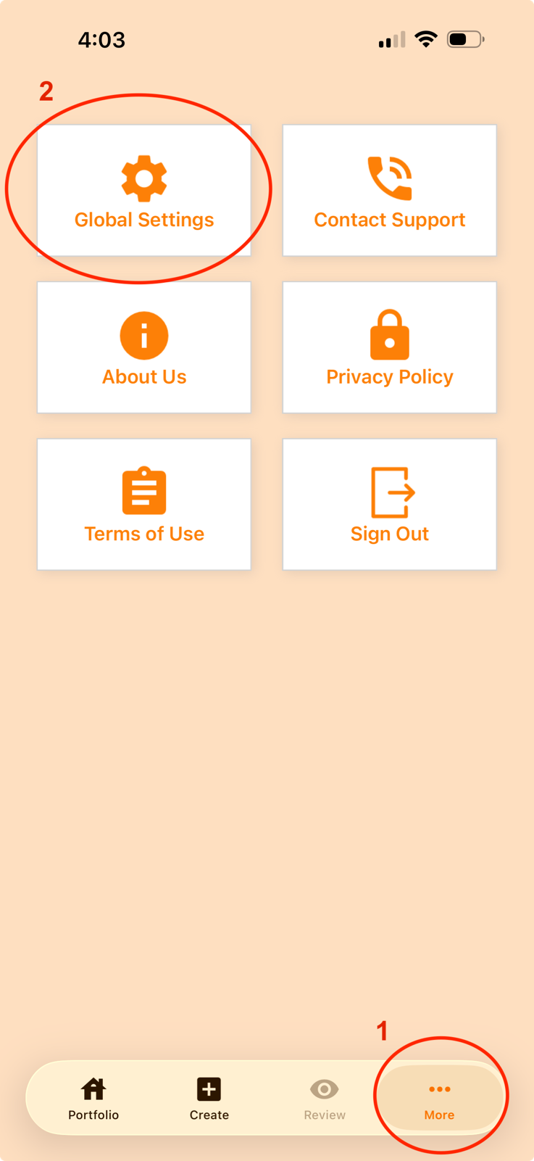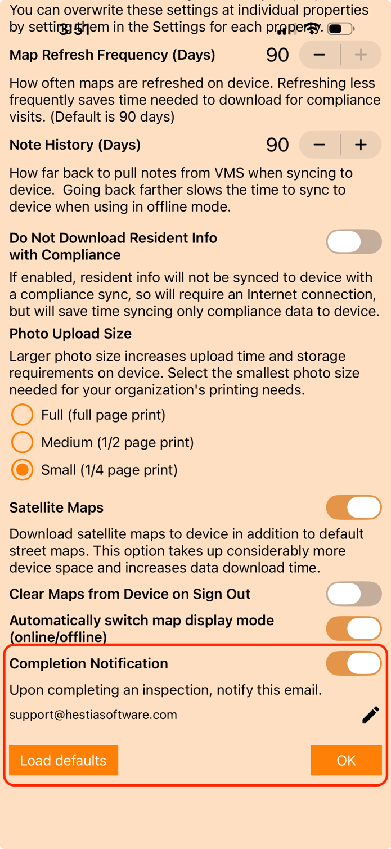
If you make any changes to your settings and want to revert to the original settings, click on Load defaults button.

Fix UTC Time default on images
Intermittent issues where an image is uploaded with the UTC time as default. The local time on device is preferred and now shown.

Updated error handling
More complete error messages added for some common user issues.

Bug fixes and performance improvements
Backend overhaul with improved stability and performance. Other minor bug fixes.

